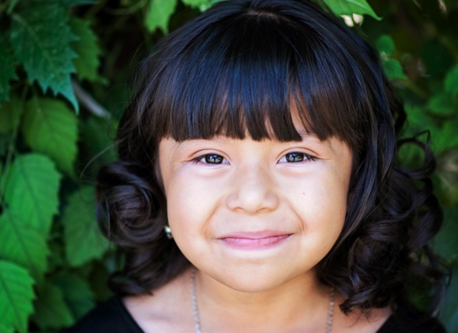
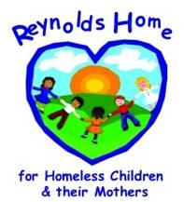
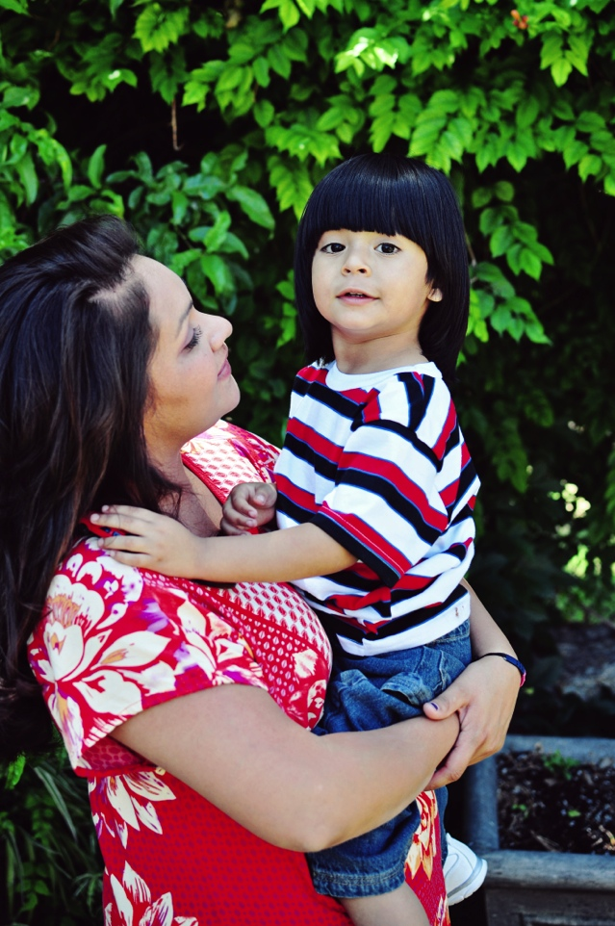

Volunteer

Donate

Intern

In-Kind

Get Involved
  - Homeless Shelter

The Reynolds Home

About Us
Program funding depends on partnerships with the community and its citizens to end and prevent homelessness.
The Reynolds Home
A Shelter for Homeless Women &
Children

8023 San Jose
El Paso, TX 79915

Contact Dorothy Truax
915-274-2598

www.reynoldshome.org

Reynolds Home is a private non-profit shelter located in the lower valley of El Paso, TX. The farmhouse, owned by Dr. and Mrs. William Reynolds, was built in 1926. The home was inherited by their daughter Virginia Tullius who set it up as a shelter for homeless women and their children in 1990 to honor her parents’ memory.
As it approaches its 35th anniversary, the Reynolds Home will accommodate 100 families with 200 children each year.

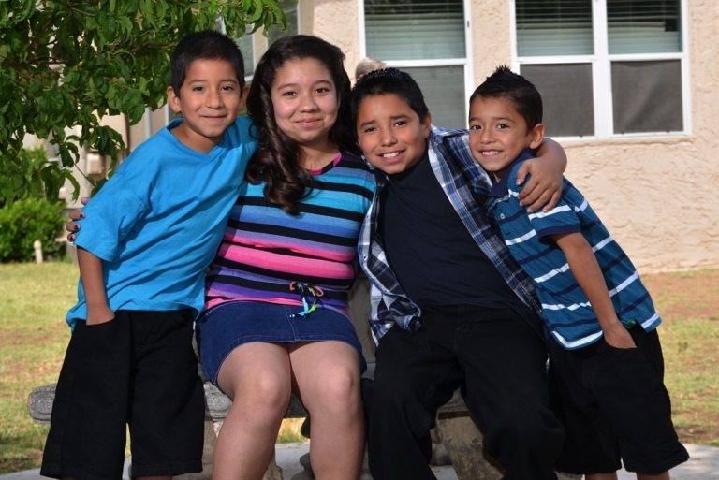
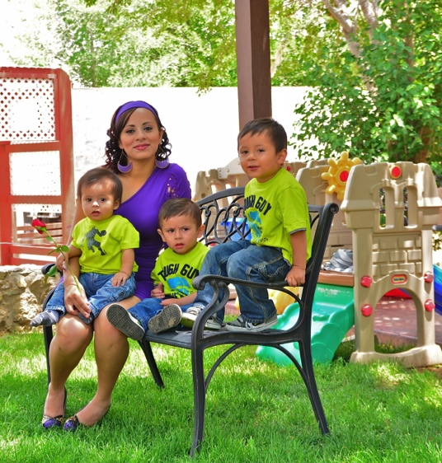
We go beyond housing and minimum-wage jobs at Reynolds Home to help clients develop skills to seize opportunities to improve their circumstances. In partnership with the Reynolds Home Beyond Shelters project, each family can access an array of services and supports to keep building on the foundation already established. Services include:
- Employment assistance
- Health and mental health assistance
- Financial counseling
- Food and nutrition
- Education

To us families aren’t “cases to be managed”; they’re people with strengths that can be enhanced to transform their lives and the life of their communities.
Services are offered to homeless women and their children in beautiful surroundings worthy of children that need a temporary stay. The home insures a strong support system forged in a family-like atmosphere where residents live, work and help each other to develop resources and skills. Our residential program involves three areas of priority:
- economic growth
- family cohesiveness
- health
Having a steady advocate alongside can make all the difference. Reynolds Home is committed to delivering that key difference and ultimately to preventing homelessness.

In the words of a former Reynolds Home resident, a 40yr old woman with three teenagers and a six-year old son: “ Thank you for pushing me to better myself and to make my own decisions.” (Stephanie)

The primary goal is to help families find a home which they can call their own, where they feel safe and together. Moms are confident that they can keep their children well and happy.

Reynolds Home provides shelter, security and basic services to women that teach and encourage mothers to cherish and respect their own dignity and to build on their own strengths. This enables them to provide independently for themselves and their children.

In Service for 35 years, the home has welcomed 1,350 families and 3500 children.

“Families with children now represent the largest…and fastest growing segment….of people experiencing homelessness in El Paso today.”

Our Mission

